SYED SUALEH ABBAS 10303

MOHSIN MUJTABA 10016

Lab 3: Implementing Jump and Return in RISC V Assembly Language
Objectives
This lab introduces RISC-V assembly instructions related to control transfer, specifically jump and return operations. Students will implement and analyze jump-based program flow using Visual Studio Code by completing a series of hands-on tasks designed to strengthen their understanding of subroutines and control flow in RISC-V.

Introduction
In this lab we will learn about:
- RISC-V Jump and Return instructions
- Handle the stack

Function calls
Functions, or procedures as they are sometimes called, are an important part of programming. They help avoid repeating the same code all over our programs. A function call would take the program flow to the start of the function code. That code will be executed, and a return from-function instruction would take the program flow back to where originally the function was called from and continue the execution from the next instruction after the function call.

Like all instruction sets, RISC-V provides special instructions to enable function calls and return from functions.

Category | Instruction | Assembly | Operation | Description
Unconditional branch | Jump and link | jal x1, 100 | x1 = PC+4; go to PC+100 | PC-relative procedure call
Unconditional branch | Jump and link register | jalr x1, 100(x5) | x1 = PC+4; go to x5+100 | Procedure return; indirect call
Table 3.1: RISC-V Unconditional Branch Instructions

You can think of a procedure like a spy who leaves with a secret plan, acquires resources, performs the task, covers his or her tracks, and then returns to the point of origin with the desired result. Nothing else should be perturbed once the mission is complete. Moreover, a spy operates on only a “need to know” basis, so the spy can’t make assumptions about the spymaster. Similarly, in the execution of a procedure, the program must follow these six steps:
- Put parameters in a place where the procedure can access them.
- Transfer control to the procedure.

- Acquire the storage resources needed for the procedure.
- Perform the desired task.
- Put the result value in a place where the calling program can access it.
- Return control to the point of origin, since a procedure can be called from several points in a program
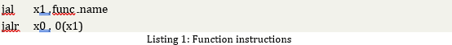

Listing 1 lists the jal and jalr instructions used for function calls and returns from functions respectively in RISC-V.

Executing jal instruction would make the program flow jump to func name label in the code while at the same time storing the address of the next instruction PC+4 in the register x1. The return address needs to be stored so that the program flow can go back to where the function call was made to continue execution from there onwards once it has finished executing the function code. Since a function can be called from multiple locations in a program, without saving the return address we will not have a clue as to where to return to. The jalr instruction is used to return from functions. The jump target address is provided in a register. The example shown in Listing 1, it will jump to the address stored in the register x1. Combining this with jal instruction we can see how the two instructions work in tandem to provide the functionality of calling a function and returning from it.

RISC-V Registers
Register | ABI Name | Description | Saved by
x0 | zero | zero register (hardwired zero)
x1 | ra | return address | Caller
x2 | sp | stack pointer | Callee
x3 | gp | global pointer
x4 | tp | thread pointer
x5–7 | t0–2 | temporary registers | Caller
x8 | s0 / fp | saved register / frame pointer | Callee
x9 | s1 | saved register | Callee
x10–11 | a0–1 | function arguments / return values | Caller
x12–17 | a2–7 | function arguments | Caller
x18–27 | s2–11 | saved registers | Callee
x28–31 | t3–6 | temporary registers | Caller
Table 3.2: RISC-V Registers

Another issue associated with function calls is passing the parameters and returning the result. As can be seen from Table 3.2, the RISC-V convention reserves the registers x10-x17 for passing parameters to a function when calling it. The caller code would fill in these registers the parameters needed by a function before calling it. Once the function is called, it will access its parameters from these registers, use them, and then return the result in x10 before calling the jalr instruction which would take the control flow to the caller who can then access the result of the function call by reading x10.

In case the registers x10-x17 contains some values, which will still be used by the caller code after the function call, the caller code needs to store these values as well as its own return address x1 on the stack before overwriting these values with the ones needed by the callee. See section 2.8 in the textbook.

Environment Calls
The Venus simulator supports some system calls, which it calls Environment Calls, as well. See the url https://github.com/kvakil/venus/wiki/Environmental-Calls. To execute an environment call we have to put its number in the register a0(x10), any argument it might need in a1(x11) and then call the ecall instruction. The simulator will perform the system call specified in the a0(x10) register.

The RISC-V environment calls can be used to print values from registers or memory in the Venus Terminal. For example, one of the supported system calls is print int whose number is 1 and which will print any value stored in the register a1(x11) in the terminal as an integer.
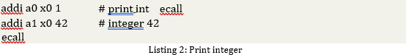

The code in listing 2, taken from the above url, would print the integer 42 on the Venus Terminal Window.

Task 1:
Write a code for the function sum shown in listing 3. It takes two integers a and b as arguments and returns their sum. You should also write code that calls this function i.e. it sets up the two arguments a and b in registers x10 and x11 and then calls sum(). After calling sum(), it then retrieves the returned result from the register x10. It can display the result using the ecall instruction.

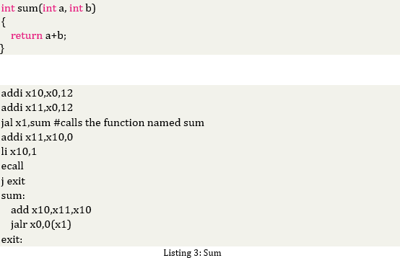

Code

.text

.globl

main:

addi x10, x0, 12

addi x11, x0, 12

jal x1, sum

add x11, x10, x0

li x10, 1

ecall

j exit

sum:

add x10, x11, x10

jalr x0, 0(x1)

exit:

Output

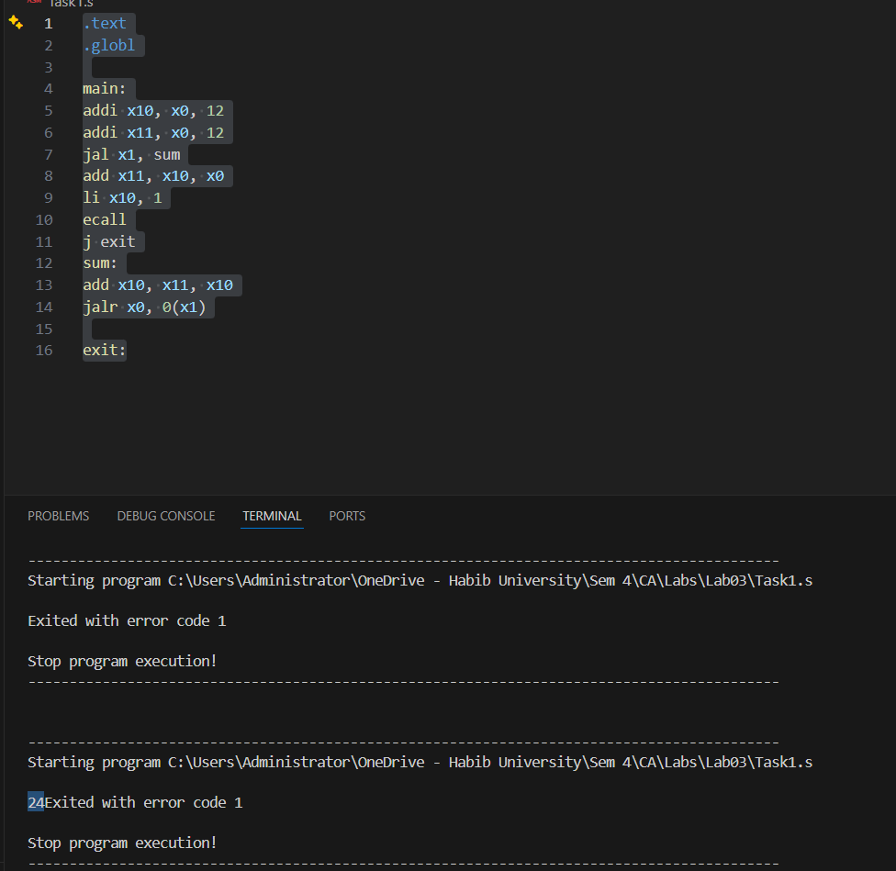

Task 2:
Have a look at a C procedure:
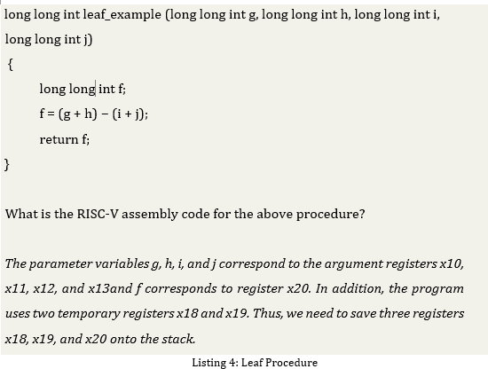

Code

.text

.globl

main:

li x10, 10 #g

li x11, 6 #h

li x12, 4 #i

li x13, 9 #j

jal x1, stack

jal x2, load

j end

stack:

addi sp, sp, -8

sw x5, 4(sp)

sw x4, 0(sp)

add x5, x10, x11

add x4, x12, x13

sub x20, x5, x4 #f

lw x4, 0(sp)

lw x5, 4(sp)

addi sp, sp, 8

jalr x0, 0(x1)

load:

li x10,1

add x11, x20, x0

ecall

jalr x0, 0(x2)

end:

j end

Output

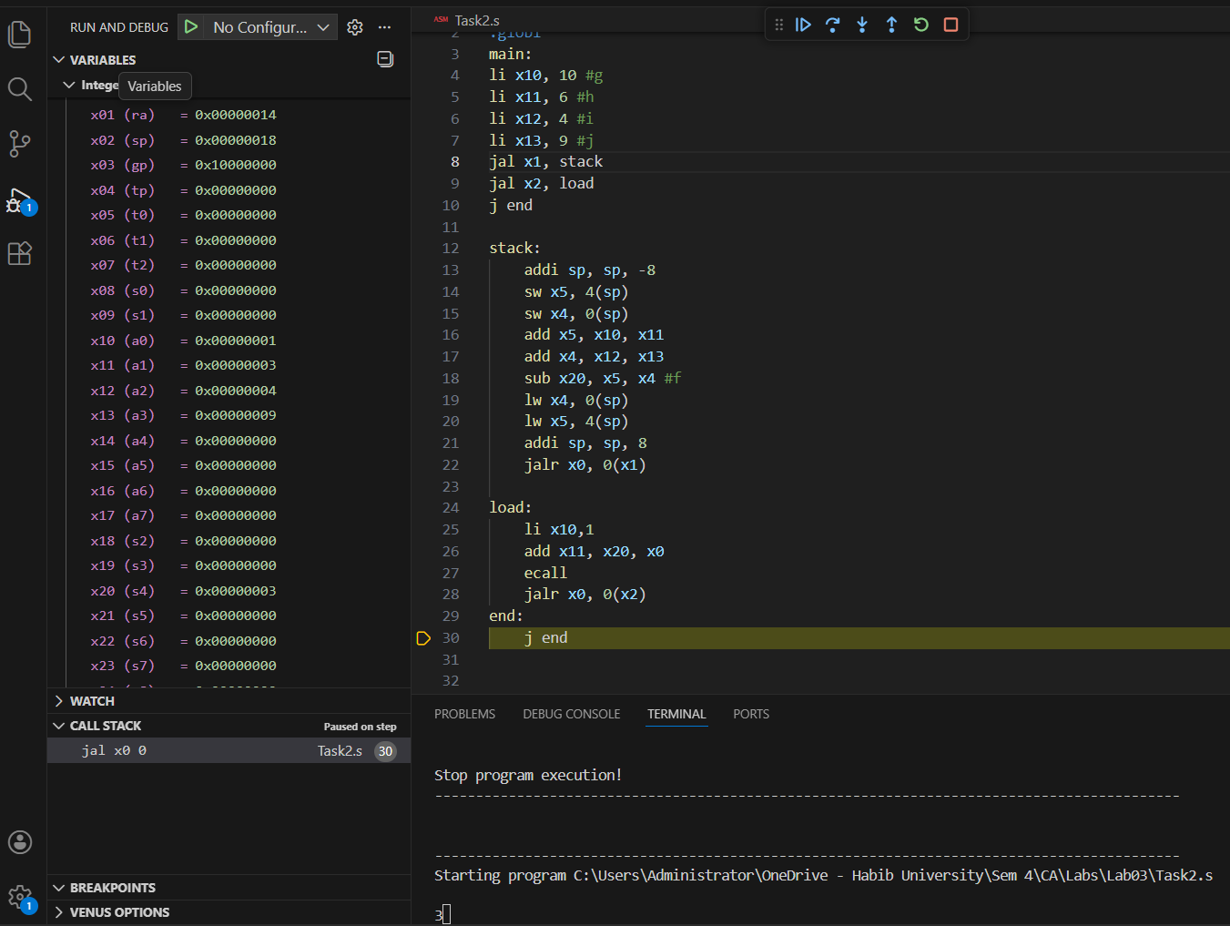

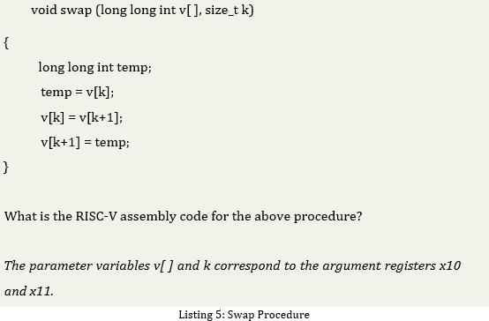
Task 3:
The following C procedure swaps two array elements (or two locations in memory)

Code

.text

.globl main

main:

li t0, 0x200 # base address

li x25, 5 # number of elements = 5

li x22, 0 # i = 0

j loop1

loop1:

bge x22, x25, swap

slli x10, x22, 2 # offset = i * 4

add t1, t0, x10

addi x11, x22, 1 # value = i + 1 (1 to 5)

sw x11, 0(t1)

addi x22, x22, 1

j loop1

swap:

li x14, 0 # k = 0

slli x16, x14, 2

add x17, t0, x16

addi x18, x17, 4

lw x19, 0(x17)

lw x20, 0(x18)

sw x20, 0(x17) # A[k] = A[k+1]

sw x19, 0(x18)

end:

j end

Output

BEFORE SWAPING:
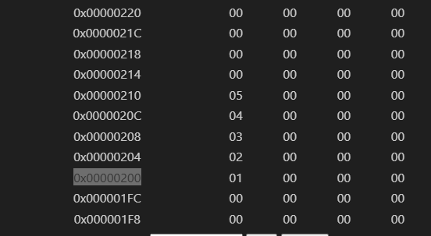

AFTER SWAPING:-

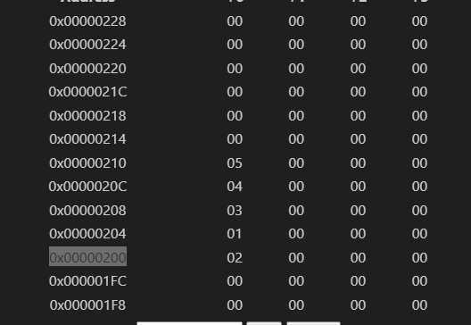

Task 4:
The procedure strcpy copies string y to string x using the null byte termination convention of C:
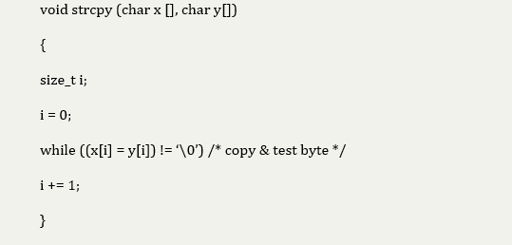

What is the RISC-V assembly code?

Code

.data

src: .asciiz "Hello World"

dst: .space 10

.text

.globl main

main:

la t0, src

la t1, dst

j copy

copy:

lb t2, 0(t0)

li t3, 32

beq t3,t2, end #stop at the ascii value of empty space

sb t2, 0(t1)

beq t2, zero, end # stop at '\0'

addi t0, t0, 1

addi t1, t1, 1

j copy

end:

j end

Output

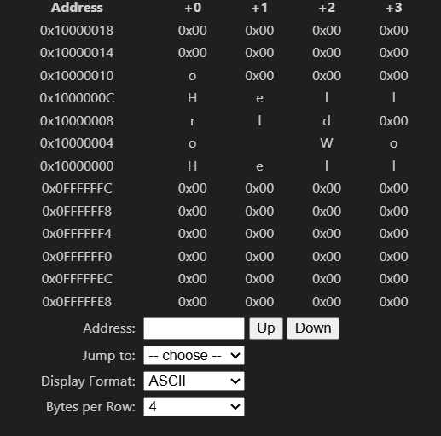

Assessment Rubric
Lab 3: Implementing Jump and Return Introductions in RISC V Assembly Language

Name: | Student ID: | Section:

Points Distribution

 | Task No. | LR 2  Code | LR 5  Results
In - Lab | Task 1 | /10 | /05
In - Lab | Task 2 | /10 | /10
In - Lab | Task 3 | /10 | /10
In - Lab | Task 4 | /15 | /10
Total Points: 100 |  | /45 | /35
CLO Mapped |  | CLO 2

Affective Domain Rubric |  | Points | CLO Mapped
AR7 | Report Submission & Git Upload | /10 & /10 | CLO 2

CLO | Total Points | Points Obtained
2 | 100
Total | 100

For description of different levels of the mapped rubrics, please refer to the Lab Evaluation Assessment Rubrics and Affective Domain Assessment Rubrics provided here.

